The doctor will virtually see you now – how one ‘forward-thinking’ GP surgery is embracing technology
  - Video consultation
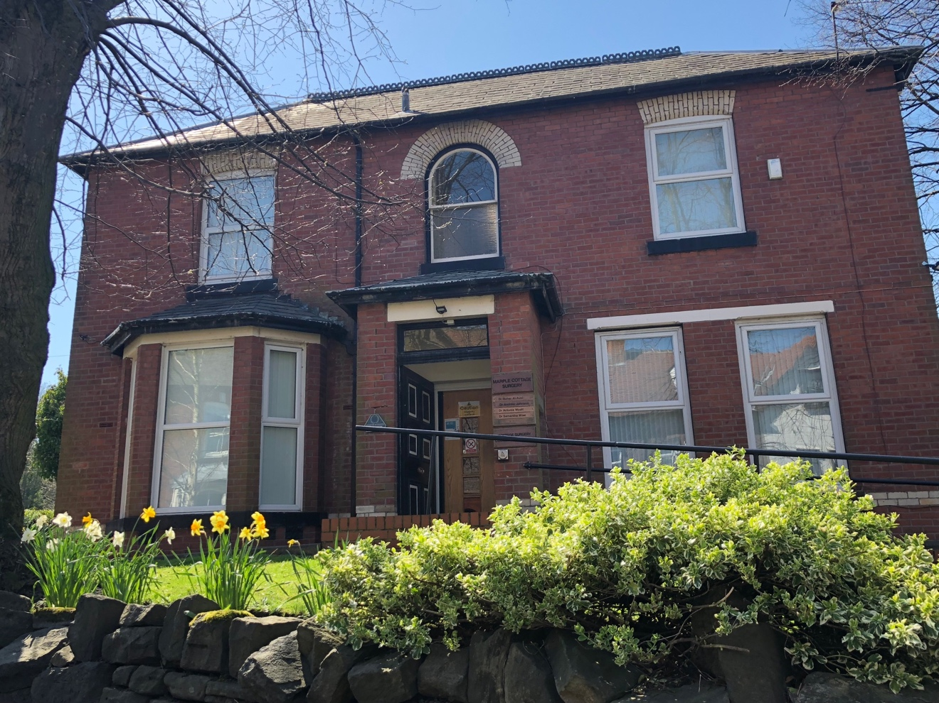

Written by Gill Hitchcock on 9 July 2018 in Features

Marple Cottage Surgery is leading NHS primary care by improving patient experience with video consultations. Gill Hitchcock finds out more
“One of my first video consultations was with a 90-year old who had severe back pain and could not get out of bed,” says Dr Maher Al-Ausi, a GP at Marple Cottage Surgery.
“Normally that would involve a home visit and half an hour’s travel, then coming back, writing up the notes and prescribing – whereas, I could see him and he could see me, and everything took less than 10 minutes.”
Located on the outskirts of Stockport, this a small-town practice with big ambitions for the NHS. A Care Quality Commission (CQC) report in April identified its “history of forward thinking and innovation”.
While other practices ponder allowing patients to email them, Marple Cottage has been enabling this for 16 years. Its virtual patient reference group has nearly 800 members and almost 82% of its patients access their medical records online.
Video consultation, which started as a pilot in 2016, is a core offer at the practice. A poll of the patients who used the service between January and December 2017, showed positive results. Based on a 45% response rate, it revealed that 100% of patients found it easy to use, and 60% did so while they were at work.
“Our culture at this practice is that we are not scared of progress. We want to innovate for all patients of all ages and across the breadth of socio-economic groups who use video consultation."
Dr Maher Al-Ausi, Marple Cottage Surgery
“We have a commuter population,” says Dr Al-Ausi. “A lot of our patients work at the university or the BBC in Salford and their free time is around lunchtime, which for us would be at the end of a surgery, or the beginning of an afternoon surgery.
“They find it very convenient to take themselves to a private room where they can have a communication with us. And if they need to be prescribed, I can just send the prescription electronically to a chemist near where they are working, or wherever they are in the country.”
It might seem that video consultations are particularly apt for younger people who are used to organising their lives online. But Marple Cottage practice manager Johan Taylor disagrees.
“Most people now in their 50s and 60s and beyond are very, very confident on computers,” he says.
The way it works is that the patient uploads a plug-in on their device. Then, after they book an appointment, the surgery’s clinical system creates a weblink which is sent to them via email or text. About 10 minutes before the appointment, the patient gets a message asking them to click on the link and enter their name. The rest is up to the GP.
Taylor says that what is unique is that the service is fully integrated with the EMIS patient record system and protected by its security. Patients understand that they cannot have a video consultation for a condition that requires an examination, but for those who want to discuss an existing problem or medication, it works really well.
Ahead of its launch, Marple Cottage piloted the service over 18 months and as Taylor says “it was not plain sailing”.

60%
Percentage of users of Marple Cottage Surgery’s video consultations who use the service at work
£45m
NHS England funding announced in October 2017 to support uptake of online consultations
82%
Percentage of Marple Cottage Surgery patients who access their medical records online
£1,500
Annual EMIS licence costs payable by Marple Cottage for providing video consultations

A major hurdle was getting the software to work with a wide range of devices, from different models of mobile phone, to laptops and tablets. But that was for the supplier, EMIS, to sort out.
The limiting factors now are bandwidth and signal strength.
“If the patient is using WiFi and they change room and get to some little black spot in their own house, that, to be honest, is a technical difficulty,” says Dr Al-Ausi. “But we get around that by saying, ‘stay in once place’. For the most part, it’s very straightforward. They download the app, click on the link, wait in a safe conference area and, when I join, they are usually already there waiting for me at the appointed time.”
Two years ago, the General Practice Forward View recognised that online consultations can improve the patient experience. NHS England promised a £45m national programme to stimulate uptake of online consultations systems for every practice.
The growth in remote consultations is, however, largely in the private sector. And, in an examination of 35 independent online primary health care providers, the CQC uncovered safety issues. Some of these – including poor monitoring of long-term conditions, lack of clinical oversight and failure to act on medicines safety alerts – were alarming.
A new business model
Professor Helen Stokes-Lampard, chair of the Royal College of GPs, sees an additional issue. Speaking at the King’s Fund’s Reimagining General Practice conference in June, she said that some private online providers “cherry pick” the healthy and the well, leaving NHS GPs with people who are expensive to look after.
“So, you have to do one of two things,” she told the event. “Totally adopt that technology right across the NHS for everybody, so it destroys the business model and is normal across the whole of general practice, or tear up the financial model by which we are paid. I would suggest that we need to do both.”
Meanwhile, Marple Cottage Surgery (pictured below left) is looking to increase the number of video consultations from the three or four it currently provides each day. It sees greater potential with people who are housebound, with virtual ward rounds in nursing homes, and it is looking to increase the proportion of remote reviews of asthma patients from the current 25%.
Asked why other GP practices have not adopted video consultations, Taylor says there is a lack of awareness and that the cost could be prohibitive. EMIS bases this on practice size, and Marple Cottage pays £1,500 annually.
“We understood the benefit, because we had piloted it, tested it and it was a question of whether we wanted to continue,” he says. “Quite simply, we liked what it did and we wanted to offer it as an alternative to our patients.”
Taylor adds: “But if you have never used it before, in the cash-strapped NHS I can understand why it would easy to dismiss. There are always early adopters of technologies, which then become contractual, like electronic appointment booking or repeat prescriptions. But at the moment this is still voluntary.”
Dr Al-Ausi says it is common for GPs from other practices to ask whether video consultations increase his workload. But he says that, if anything, it reduces it – such as with the care of the 90-year old patient with back pain.
“Our culture at this practice is that we are not scared of progress. We want to innovate for all patients of all ages and across the breadth of socio-economic groups who use video consultation. I would say, have faith. It is the future – give it a try.”

